
2020-2021

Florida Sterling

Independent Evaluation

Examiner Handbook

Copyright 2020, Florida Sterling Council
All rights reserved. No part of the copyright material in this book may be reproduced or utilized in any form or by any means, electronic or mechanical, including photocopying, recording, or by any information storage and retrieval systems, without written permission from the Florida Sterling Council.

To contact the Florida Sterling Council for information or to comment, please call (850) 922-5316.
Inquiries should be addressed to:
Florida Sterling Council, P.O. Box 13907, Tallahassee, FL 32317-3907
www.floridasterling.com

Examiner Evaluation Phases
Site Visit
Team + Applicant
Feedback Report
Consensus
Team
Consensus Scorebook
Site Visit Strategy
Independent Evaluation (IE)
Examiner
Key Factors Worksheet
IE Scorebook

Independent Evaluation (IE)
Examiner
Key Factors Worksheet
IE Scorebook

Key Independent Evaluation (IE) Steps

Conflict of Interest

Key Factors Worksheet
- Business Overview Call(s)

Individually Assess Applicant Responses Against Evaluation Factors

Independent Evaluation (IE) has 2 Stages
Pre-Independent Evaluation
Key Factors Worksheet
Business Overview Call
Independent Evaluation
Assess the Application
Write IE Comments
Score

Estimated Examiner IE Time Commitment

- Approximately 20-50 hours, depending on the length and complexity of the application.
- Approximately 2 hours to participate in the Business Overview call(s) with the organization.
- Independent Evaluation Scorebook files must be completed by a specific date determined by the Team Leader.

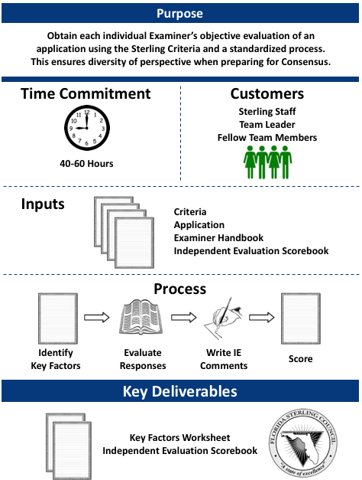

Independent Evaluation At-A-Glance

Sterling Examiners:
- Set aside adequate time to complete your work assignments and ensure confidentiality of all materials.
- Actively participate in all team conference calls.
- Follow the Handbook instructions and samples.
- Submit all assignments on time.
- Be open to feedback from your Team Lead and team members.

Key Evaluation Steps
- Set up access, log-in, and get familiar with Apex (Stratex).
- Verify that you have no conflict of interest with the Applicant organization.
- Review materials (criteria, handbook, application).
- Prepare the Key Factors Worksheet file.
- Prepare for and participate in the Business Overview call.
- Evaluate the applicant responses to the criteria for each Category/Item (categories 1 through 6)
- Score each Category Item.

Get Started in Apex
Log in to Apex (Stratex) | Go to the following website to access Apex. From the top-right corner of the ribbon, click on “Log in.”  https://apex.stratexsolutions.com  Enter in the email used for registration and the password you selected during registration.  - You may select “Remember Me” to save your log in credentials on the same device and web browser.
Application Download | Download the Application.  To access your assigned application, click on the “Evaluation” drop-down arrow and then the “Home” button in the upper left-hand corner of the ribbon.  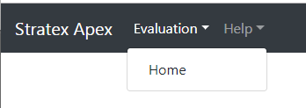  Next, click “Review” in the Actions column next to your assigned assessment/application under the section titled “Your Assessment Evaluation List.”  As you work through the entire assessment process, the “Review Stage” will update to reflect in which stage you are currently working.  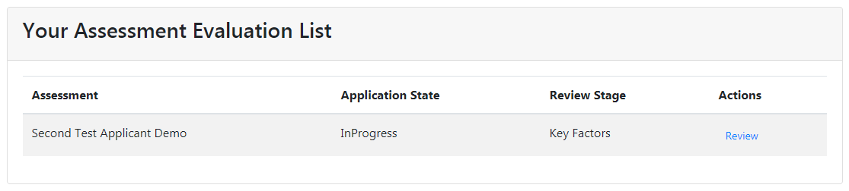  Application Download  There are two options to retrieve the application to download.  - Click “Application Download” from the left navigation menu.  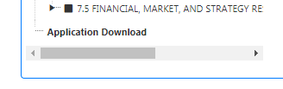  OR  - Click “Evaluation” from the top ribbon then “Application Download”  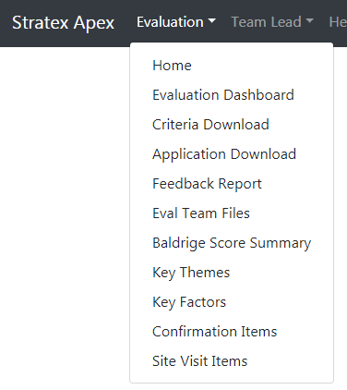  Both methods will take you to the Application Download section. From there, you will click “Summary Application” to complete the download.  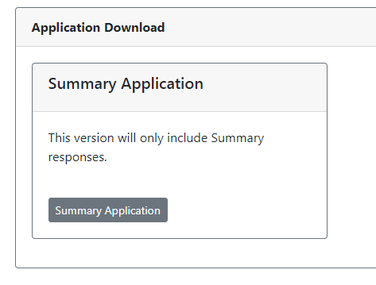
Conflict of Interest | Verify you have no conflicts of interest with the assigned application:  - Review the Applicant’s Eligibility Certification Form and Organizational Profile for overall information about the organization.  - Pay particular attention to the organizational charts, key customers, competitors, suppliers, partners, and collaborators.  Notify the Sterling Office and your Team Leader immediately if you identify any situation that may be perceived as a conflict of interest.

Identify Key Factors
Identify  Key Factors | Key Factor: an organizational attribute that influences the way the organization operates and is important to its success. Examiners use the Key Factors to focus their evaluation on what is important to the organization.  Refer to the Case Study Key Factors Worksheet for a complete sample.  Summarize the Organizational Profile in the Key Factors Worksheet.  - Download the Key Factors Worksheet from Box  - “Save As” using the following naming convention: Applicant code-Key Factors-Your Initials. Example: PS03-KeyFactors–PLD  - Read the Criteria questions for Organizational Profile Items P.1 and P.2.  - Read the Organizational Profile for the applicant’s responses.  - Record Key Factors based on the organization’s responses, in order; each Key Factor is on a separate line in the table, but do not number.  - Upload your completed Key Factors Worksheet as instructed by your Team Lead.  - Eval Team Files –  - This section in Apex allows files to be uploaded and stored in the system. Once you have selected “Eval Team Files” from the Evaluation dropdown menu, you are able to upload files to be stored.  - The various allowable formats are listed under “Image Load.” Select “Choose File” to browse for the file you would like to upload. Once you have searched and selected your desired file, click on “Open.”  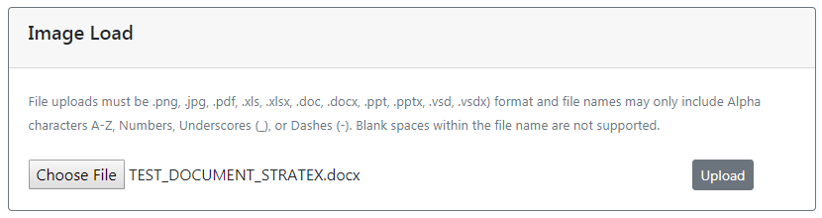  - Your Team Lead will coordinate the team’s consensus on the Key Factors that all Examiners will use during Independent Evaluation.  - The Team Lead will designate a member of the team to complete the consented Key Factors within Apex.  - Examiners must use the Key Factors-Consensus for Independent Evaluation.
Sample Key Factors Worksheet:
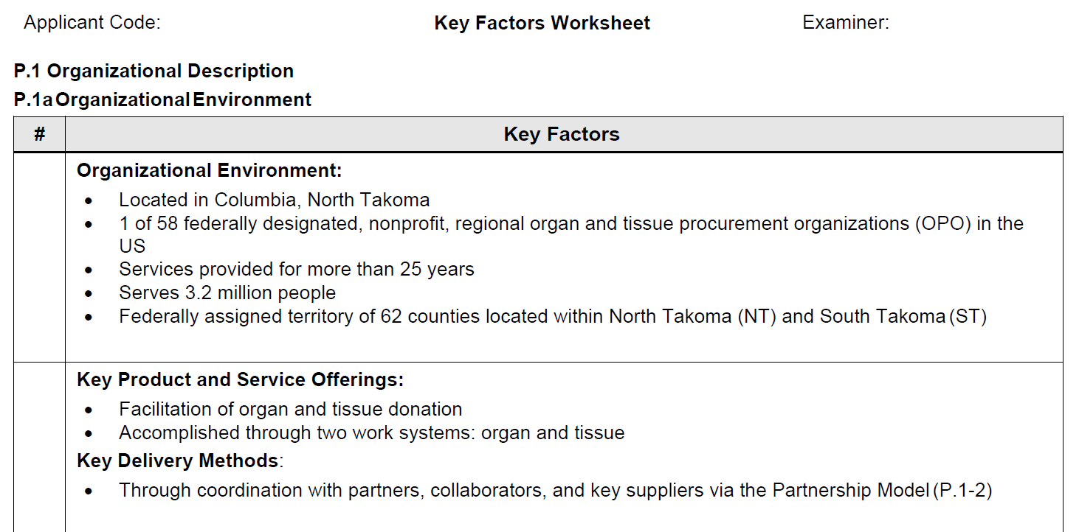

Business Overview Call(s)
Scheduled Conference Calls / Video Sessions | All Sterling evaluation phases will be done virtually.  - The only exceptions are the Key Factors Worksheet and the (fairly remote) possibility of a 2 or 3-day in-person Site Visit.  - There will be team and applicant calls/video (e.g. Zoom, etc.) at least weekly. These calls/video include team-only (using its platform) and the team-applicant interview calls (on the applicant’s platform) for Results and Process Items.  - The entire Sterling team may or may not be required to participate in every call.  - The Team Lead will set up the call schedule for the entire evaluation process: Independent Evaluation, Consensus, and Site Visit.  - Most calls/sessions will be scheduled for an hour or up to two hours each.  - There can be little or no excuse for not participating in the calls. We hope this will be at least a little more flexible for your schedule than being totally away from your home and work (from 5 to 9 days) for consensus and site visit.
Business Overview Call | - The first scheduled team call with the Applicant will be the Business Overview. The purpose is to validate the Key Factors and to better understand the organization’s business and culture.  - Depending on the size and complexity of the organization and the Sterling team members, this may be a single call or may require two calls.  - The Business Overview sets the foundation for beginning the Independent Evaluation of the application.
Process and Results Evaluation Calls / Video | - Weekly Results Item calls may start during the Independent Evaluation phase.  - The Examination team members may be required or recommended to listen in on Results calls.  - The purpose is to understand what the organization measures and why, this helps examiners to better evaluate the Process Items against the criteria and the Key Factors.  - At the conclusion of the Independent Evaluation phase there will be Consensus Results and Process Item calls scheduled; again, all team members may be required to participate; these calls are the Consensus phase for the team.

Independent Evaluation
At-A-Glance

Independent Evaluation (IE):
- Use the Consensus version of the Key Factors Worksheet for your Independent Evaluation.
- Prepare and submit your one assigned Item.
- Participate in all scheduled calls / video sessions.
- Complete and submit your Independent Evaluation Scorebook.
- Do not email any evaluation files or applicant-related files; all files must be stored and accessed through Apex following your Team Leader’s instructions.

Independent Evaluation Instructions
Your Team Lead will assign an Item, or part of an Item, from a particular Category to submit early in the evaluation process. This is to ensure that you understand the IE process and to provide you with prompt feedback to help you through the rest of the process.
Complete your evaluation (comments & scoring) of an Item prior to starting the next Item.
Example: complete 6.1 before starting 6.2.
Access IE in Apex | Access Application  To access your assigned application, click on the “Evaluation” drop-down arrow and then the “Home” button in the upper left-hand corner of the ribbon. Next, click “Review” in the Actions column next to your assigned assessment/application under the section titled “Your Assessment Evaluation List.” As you work through the stages of the process, the “Review Stage” will update to reflect in which stage you are currently working.
Read the Criteria | - Read the criteria requirements to which the organization may respond.  - Note key words / phrases to aid your review.  - Copy, then paste the parts of the criteria that you need for your comment content.  - All criteria words used in your IE comments must be bold.
Select Key Factors | - For each Item, based on the criteria, select the most relevant 4 to 6 Key Factors.  - Apex Key Factor Association:  To identify the relevant key factors within an Item Number, use the “Key Factors – Association” portion when viewing at the Item Level.  - Select the key factor you wish to associate from the drop-down arrow then click “Associate”.  - Repeat this step until all desired key factors are selected.  - Key Factors will vary among the Items depending on the criteria.  - To disassociate a Key Factor, click on the “-“ (minus) symbol.
Evaluate Applicant’s Response | Read the organization’s response for the Item.  - Highlight, flag, mark-up, and/or take notes on content;  - Note what the organization is or is not doing relevant to the Criteria. If there is information provided elsewhere in the application that applies to the Item, include the information in your comment;  - Note any measures (Results) you might expect to see relevant to the content;  - Do not use the Criteria as a checklist. Use the Key Factors to determine which multiple requirements are most important / relevant to the organization;  - Evaluate using the A, D, L, and I Evaluation Factors.

Evaluation Factors: A D L I

A D L I  Approach | Approach (A): refers to the methods used by an organization to address the Criteria Item requirements in Categories 1-6. Approach includes the appropriateness of the methods to the Item requirements.  - Is the approach systematic; i.e., repeatable steps, inputs, outputs, time frames?  - Is there evidence that the approach is effective?  - Is this approach (or collection of approaches) a key organizational process?  - Is the approach important to the applicant’s overall performance?
A D L I  Deployment | Deployment (D): the extent to which an approach is applied to address the Item requirements. Evaluate deployment based on the breadth and depth the approach is applied to relevant work units and/or people throughout the organization.  - Is deployment addressed?  - What evidence is presented that the approach is in use in all appropriate work units, facilities, locations, shifts, organizational levels, and so on?
A D L I  Learning | Learning (L): in evaluation factor context, refers to new knowledge or skills acquired through evaluation, study, experience, and innovation.  - Has the approach been evaluated and improved? If it has, was it conducted in a fact-based, systematic manner—e.g., was it regular, recurring, data driven?  - Is there evidence of organizational learning—evidence that the learning from this approach is shared with other organizational units/other work processes?  - Is there evidence of innovation and refinement from organizational analysis and sharing—evidence that the learning is used to drive innovation and refinement?
A D L I  Integration | Integration (I): As a process evaluation factor, integration covers the array from alignment of approaches in the lower scoring ranges to integration of approaches in the higher ranges.  Alignment refers to consistency of plans, processes, information, resource decisions, actions, results, and analyses to support key organization-wide goals. It requires complementary measures and information use to plan, track, analyze, and improve at three levels: organization, key process, and work unit.  Integration refers to harmonization of plans, processes, information, resource decisions, actions, results, and analyses to support key organization-wide goals. Effective integration goes beyond alignment and is achieved when individual performance management system components operate as a fully interconnected unit.  - How well aligned is the approach with the organizational needs identified in other Criteria Items and the Organizational Profile?  - Are complementary measures and information used to plan, track, analyze, and improve on three levels: organizational, key process, and department or work-unit?  - How well is the approach integrated with organizational needs—strategic challenges, objectives, related action plans; mission, vision, goals; key processes and measures; key customer/market segments and requirements; and employee groups and requirements.

Evaluation Factors: +I & R
+I (Innovation) and R (Results)
+I: For each Strength comment note any examples of Innovation, if none found, so note.
R: For each Strength and OFI comment correlate with results, as appropriate.
+I  Innovation | Innovation: Making meaningful change to improve products/services, processes, or organizational effectiveness and create new value for stakeholders.  - Review the application for evidence of Innovation – this is especially important for higher-scoring organizations. Record specific examples of innovation in the column; if missing note with “N/A” or “None” in the Integration column.
R  Results | Correlate your comments with the results included in Category 7.  Based on each of your Strength and OFI comments, determine what key results you would expect to see in Category 7. Refer to your notes on results from your initial reading of the application.  - Read each comment to determine whether or not you would expect to see numerical results; briefly note your expected results; if results would not be expected for the comment, note “N/A” in the Results column.  - To find expected results use the Typical Results Locations (below) to see where you might find the specific charts, information, etc. that align to what you expect.  - Go to Category 7; if you find the results you expect, record the Figure number(s) in the Results column for the comment  - Review the charts and information to determine whether the results support your process comment.  - Note: If results do not align to your Strength or OFI comment, you may need to re-think your comment. Example: you have an OFI for lack of customer segmentation, but most of the data are segmented by customer group.
Typical Results Location (exact location will vary by organization)
Process Category |  | Results Typically Found In…
Category 1 - Leadership |  | 7.4: Leadership and Governance Results (leadership, governance, laws/regulations, ethics, societal, strategy implementation).
Category 2 - Strategy |  | 7.5: Financial and Market Results and 7.4b Strategy Implementation Results.
Category 3 - Customers |  | 7.2: Customer Results
Category 4 - Measurement, Analysis, Knowledge Management |  | 7.1 thru 7.5: Organizational Performance & Improvement Results
Category 5 - Workforce |  | 7.3: Workforce Results (capability/capacity, climate, engagement, development)
Category 6 - Operations |  | 7.1: Product, Service, and Process Results (customer-focused product/service outcomes, work process effectiveness/efficiency, safety/emergency preparedness, supply-chain management)

Develop 5-8 Key Ideas for Each Item
Develop Key Ideas | Make a list of key ideas for Strengths and Opportunities for Improvement (OFIs) for the Category Item. Prioritize your list into the 5-8 most relevant / significant ideas (strengths and OFIs) to capture your evaluation for each Process Item.  - Review the organization’s response to the Item Criteria keeping in mind the Key Factors you identified for the Item;  - Consider the organization’s response to the evaluation factors (A, D, and L); identify significant Strengths and any significant gaps (OFIs) for A or D or L;  - Determine the 5 to 8 highest priority thoughts in terms of Key Factors that will best illustrate Strengths and what is lacking for OFIs. These provide the basis for comments  - Each thought/comment should be strongly linked to the Criteria words in bold. Example:  - “The organization has a systematic process for determining key factors that affect workforce engagement.”  - Similar thoughts may be combined. Example:  - “Methods for determining key factors that affect workforce engagement and survey devices used for assessing engagement and satisfaction include……”  - If there is an apparent gap (OFI) in a single evaluation factor (such as “Learning”), you may develop a single comment for the Item on just that factor.

Write IE Comments
Write 5-8  IE Comments for A,D,L,I | An Independent Evaluation (IE) Comment is a statement of findings; it is a set of fragment statements (you may bullet longer statements) structured into distinct content elements below.  - Comments are based on your prioritized list of 5 to 8 key ideas for each Item.  - Identify the 4 to 6 Key Factors most relevant/important to the organization for each Item (1.1, 1.2, 2.1, etc.).  - The Criteria are pre-populated in all evaluation files.  - Copy then paste the Criteria words used in each comment – bold all Criteria words used.  - Refer to the Comment Guidelines file for details on good comment writing.
Comments in Apex | Add a Comment  To add a comment, use the Apex section titled “Feedback”. Use the “Type” to indicate a Strength comment or an OFI (opportunity for improvement) comment.  - Click to place a check mark next to the elements you have identified in the comment, i.e., approach, deployment, learning, integration, or innovation.  - Type your comment in the text field.  - To copy and paste directly from the applicant response:  - Highlight the text, right click on your mouse and select/click “copy”. This will copy the desired text. Then, click the mouse in the comment box where you would like to place the copied text, right click on your mouse and select/click “paste”.  - If you prefer using the keyboard “Control + C” and “Control + P” functionality instead of the mouse, this will also work.  - Click “Save” to save the comment.  To edit a comment in Apex once it has been saved, follow the below steps.  - Click on the Edit and your comment will appear back in the “Add/Edit Comment” section.  - Once you have finished editing your comment, click “Save”.
I.E. Strength Comment - Apex | + Apex Strength Comment:  - A: Approach: Criteria Statement + How to summarize the strength. After the criteria words provide a brief explanation of the strength and add “how” the organization addresses the requirement (i.e., the process name, brief method description, etc.). Include specific evidence from the application of how the organization operates relative to the Approach.  - Note: if you do not have a Strength comment, leave blank.  - D: and/or L: Include relevant parts of the criteria (as appropriate) and specific evidence/examples in the application of how the organization operates relative to the Criteria as appropriate.  - Integration: enter the most relevant Key Factor # and brief description for the comment.  Apex Strength Comment Format:  - Type of comment should be “strength.”  - Place the initial for Approach, Deployment, Learning, Integration, Innovation, and Results, where appropriate, followed by a colon. Example: A: (for approach).  - All criteria language used must be in bold. Example: The organization listens to, interacts with, and observes customers to obtain actionable information using various methods and are the same for both customer groups.  - Use one hard enter to create space between each initial, A, D, L, I, I, and R (sample below).
I.E. Strength Comment Format - Apex

Notes – Strength Comments | - Strength comments may include strengths in A, D, L, and/or +I (Innovation), as appropriate.  - I.E. comments do not include the I (Integration); it is only to note to link the appropriate key factor.  - I.E. Comments do not include the R (Results); notes about related results are only to validate the comment.  - The Integration and Results columns are to be completed for all comments (Strengths & OFIs).  - You may have both a Strength and OFI comment for the same Criteria Area to Address [e.g., 3.2a (1)], but for different parts of the criteria.
I.E. OFI Comment Format - Apex | - Apex OFI Comment:  - Criteria Statement: Criteria Requirement and gap: to summarizes the OFI.  Be specific about the unaddressed Criteria requirement—the opportunity. The Criteria Statement is the lead sentence in the appropriate column (A, D, or L) followed by example(s) of the possible gap.  - A, D, or L Examples: specific application evidence (A, D, or L) of what the organization is not doing or is not apparent in the written application that may be important to its performance relative to the Criteria and its Key Factors.  - I: So-What: enter the most relevant Key Factor # (I column), to indicate why this opportunity is relevant and important to the organization.  OFI Comment Format:  - Type of comment should be “OFI.”  - Put a check mark next to the type of OFI you are writing about, i.e., approach, deployment, learning, or integration.  - Any criteria words used should be in bold.  - Include the relevant Key Factor by typing I: to indicate Integration and list the key factor number and title.
Notes – OFI Comments | - Process Item OFIs are only Approach, or Deployment, or Learning.  - All Independent Evaluation and Consensus OFI comments start with,  - “It is not clear….” or “It is not evident….”  - The Integration and Results columns are always to be completed for all comments.  - Independent Evaluation phase Process Item comments do not include the I (Integration is only a note to link the appropriate key factor).  - Independent Evaluation phase Process Item comments do not include the R (Results notes are only to validate the comment).

OFI Comment Example
Criteria Statement: Using the Criteria and Applicant responses, write a statement summarizing what is unclear or not evident; provide example(s) for the A, D, or L not met in the application. Note: this is an example of an Approach OFI.

Scoring Instructions
Determine the Item Score | Factors to Determine the Score Range:  - Review the criteria requirements and your comments. Note the balance and importance of Strengths and OFIs relative to the criteria requirements and Key Factors.  - Read the scoring guidelines in the Resource Guide (or the Score Factors/Ranges below) for each factor (ADLI) starting with Approach;  - Start at the 50-65% range, consider the organization’s achievement level. Then read the next higher range; and/or the next lower range to determine if the Factor scores within, above, or below the 50-65% range.  Note: if there is no evidence of Innovation, the score range cannot be higher than 50-65%.  - Complete your review of each factor (A,D,L,I) and its best range for each.  - Determine the Overall Score Range based on the relative importance of each of the ADLI factors and whether scores were at the higher or lower end of the range.  NOTE: The organization need not satisfy all four evaluation factors  in a given scoring range.  Rather, select the range that is most descriptive  of the organization’s achievement level for that Item.

Scoring Factors and Ranges
Factors
Approach | No systematic approach to Item requirements is evident; information is anecdotal. |  | The beginning of a systematic approach to the basic requirements of the Item is evident. | An effective, systematic approach, responsive to the basic requirements of the Item, is evident. | An effective, systematic approach, responsive to the overall requirements of the Item, is evident. | An effective, systematic approach, responsive to the multiple requirements of the Item, is evident. | An effective, systematic approach, fully responsive to the multiple requirements of the Item, is evident.
Deployment | Little or no deployment of any systematic approach is evident. |  | The approach is in the early stages of deployment in most areas or work units, inhibiting progress in achieving the basic requirements of the Item. | The approach is deployed, although some areas or work units are in the early stages of deployment. | The approach is well deployed, although deployment may vary in some areas or work units. | The approach is well deployed, with no significant gaps. | The approach is fully deployed without significant weaknesses or gaps in any areas or work units.
Learning | An improvement  orientation is not evident; improvement is achieved through reacting to problems. |  | Early stages of a transition from reacting to problems to a general improvement orientation are evident. | The beginning of a systematic approach to evaluation and improvement of key processes is evident. | A fact-based, systematic evaluation and improvement process and some organizational learning, including innovation, are in place for improving the efficiency and effectiveness of key processes. | Fact-based, systematic evaluation and improvement and organizational learning, including innovation, are key management tools; there is clear evidence of refinement as a result of organizational-level analysis and sharing. | Fact-based, systematic evaluation and improvement and organizational learning through innovation are key organization-wide tools; refinement and innovation, backed by analysis and sharing, are evident throughout the organization.
Integration | No organizational alignment is evident; individual areas or work units operate independently. |  | The approach is aligned with other areas or work units largely through joint problem solving. | The approach is in the early stages of alignment with basic organizational needs identified in response to the Organizational Profile and other Process Items. | The approach is aligned with overall organizational needs identified in response to the Organizational Profile and other Process Items. | The approach is integrated with current and future organizational needs identified in response to the Organizational Profile and other Process Items. | The approach is well integrated with current and future organizational needs identified in response to the Organizational Profile and other Process Items.
Ranges | 0 - 5% |  | 10 - 25% | 30 - 45% | 50 - 65% | 70 - 85% | 90 - 100%
Enter the Score and Range |  | Scoring in Apex  To score your item, use the left navigation menu to click on the Criteria Item you are wanting to score. Use the drop-down arrows to select your Score Range and Your Score. It is important to note that you don’t actually click anything to save your score. It will automatically save upon selection.

Review and Submit Final IE Scorebook
Review Your Work | Review each Item to be sure ….  Comments:  - Criteria words are bold and include only the criteria words your comment addresses;  - Specific example/s for A, D, L, and/or +I (as appropriate) as they relate to the Criteria;  - Relevant Key Factor identified in Integration column for each comment;  - No conflicts between Strengths and OFIs;  - Results completed for each comment, as appropriate;  - Innovation if there is evidence of innovation you must include a specific example.  Scores:  - Scoring completed for all Category Items 1.1 through 6.2;  - Score Range and Numeric Score completed for each Category Item  In Addition:  - Compare Key Factors on your Item Worksheets with the Key Factors Worksheet.  - Determine if any unused Key Factors should be added to your Item evaluations. Note any additional Key Factors identified during your evaluation process.
Submit IE Comments | Submit your completed work on time.  - Notify your Team Lead when your IE comments have been completed.

